

Name: J.Vishnu Vardhan
Reg No: 192324297
Course Code: DSA0201
CO3 ASSESSMENT TOOL1 EXPERIMENT
Computer Vision with OpenCV (DSA0201)

Rubric Reference (applies to all 5 experiments)

Criteria | Weightage | What Level-4 (Exemplary) Looks Like
Understanding of Concepts | 25 | Explain the theory correctly, in your own words, and connect it to why this technique suits the given scenario.
Experimental Design | 30 | A clear, systematic pipeline: input -> preprocessing -> algorithm -> output, with reasoning for each parameter choice.
Use of Tools | 20 | Correct, idiomatic OpenCV/NumPy usage; functions configured appropriately for the input data described.
Analysis of Results | 15 | Interpret YOUR actual output images/plots: what worked, what failed, why, and how you'd improve it.
Documentation | 10 | Structured write-up with problem statement, method, your code, your screenshots, and your conclusions.

Experiment 1: Contour-Based Representation & Fourier Descriptors
Scenario: Represent 2D shapes (hand-drawn letters A-Z or symbols like triangle, square, star) using contours and Fourier descriptors. Input: 256x256 binary PNG/BMP images.

Concept Summary
    - A contour is an ordered sequence of boundary points of a connected shape, found via cv2.findContours() on a binary image.
    - Each boundary point (x, y) can be represented as a complex number z(k) = x(k) + i*y(k), turning the contour into a 1-D discrete signal.
    - Applying the Discrete Fourier Transform (DFT) to this complex signal gives Fourier Descriptors (FDs): the low-frequency coefficients capture the overall shape, high-frequency coefficients capture fine detail/noise.

    - FDs can be made invariant to translation (drop the DC/0th coefficient), scale (normalize by the magnitude of the first non-zero coefficient), and rotation/start-point (use magnitude only, ignore phase) -- useful for shape matching and recognition.
    - Truncating to the first N descriptors and taking the inverse DFT reconstructs an approximate shape -- demonstrating that a shape's boundary can be compactly encoded.

Experimental Design (Pipeline)
    - Load image -> convert to binary (threshold / Otsu) -> optional morphological cleanup (open/close) to remove noise.
    - Extract the outer contour with cv2.findContours(..., cv2.RETR_EXTERNAL, cv2.CHAIN_APPROX_NONE).
    - Convert the contour point list to a complex sequence z = x + i*y.
    - Compute DFT of z using np.fft.fft().
    - Normalize descriptors for translation/scale/rotation invariance.
    - Reconstruct the shape using an inverse FFT with only the first K coefficients, for several values of K (e.g., 4, 8, 16, all), and compare visually.

Template Code
import cv2
import numpy as np
import matplotlib.pyplot as plt

# 1. Load and binarize
img = cv2.imread("shape.png", cv2.IMREAD_GRAYSCALE)
_, binary = cv2.threshold(img, 127, 255, cv2.THRESH_BINARY | cv2.THRESH_OTSU)

# 2. Find the largest external contour
contours, _ = cv2.findContours(binary, cv2.RETR_EXTERNAL, cv2.CHAIN_APPROX_NONE)
contour = max(contours, key=cv2.contourArea).squeeze()

# 3. Build complex boundary signal
z = contour[:, 0] + 1j * contour[:, 1]
# 4. Fourier descriptors Z = np.fft.fft(z)

# 5. Translation / scale invariance Z_norm = Z.copy()
Z_norm[0] = 0 # remove translation (DC term)
Z_norm = Z_norm / np.abs(Z_norm[1]) # normalize by first harmonic magnitude

# 6. Reconstruct shape from first K descriptors def reconstruct(Z, K):
Zc = np.zeros_like(Z) Zc[:K//2] = Z[:K//2]
Zc[-K//2:] = Z[-K//2:]
z_rec = np.fft.ifft(Zc) return z_rec.real, z_rec.imag
for K in [4, 8, 16, len(Z)]:

x_rec, y_rec = reconstruct(Z, K) plt.plot(x_rec, y_rec, label=f"K={K}")
plt.gca().invert_yaxis(); plt.axis("equal"); plt.legend() plt.title("Shape reconstruction vs number of Fourier descriptors") plt.savefig("exp1_reconstruction.png")

Output (synthetic star image — NOT your data)
The image below was produced by running the code above on a computer-generated star shape, so you can see what correct output looks like. Replace it with output from your own hand-drawn letter/symbol image before submitting.
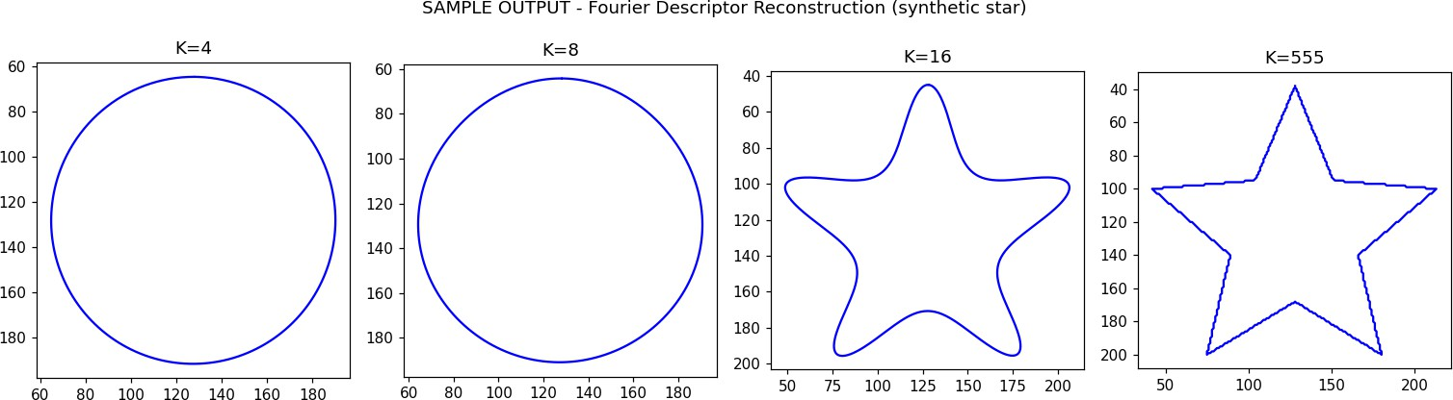
Fig. 1 — SAMPLE reference output: Fourier-descriptor reconstruction at K = 4, 8, 16, and all coefficients, synthetic star. Replace with your own result.

Documentation Checklist — fill this in with YOUR results
    - insert the original binary image and the extracted contour overlay]
    - insert the reconstruction plot for K = 4, 8, 16, all]
    - at what K does the reconstruction become visually indistinguishable from the original? What does this say about where shape 'information' is concentrated in the frequency domain?]
    - how did normalization affect matching two shapes of different sizes/rotations, if you tested that?]

Experiment 2: Region-Based Representation & Medial Axis
Scenario: Analyze industrial component shapes (gears, machine parts) using the medial axis / skeleton. Input: 512x512 binary PNGs, possibly with defects (holes, protrusions, missing parts).

Concept Summary
    - Region-based representation describes a shape by the set of pixels it occupies (not just its boundary) -- useful features include area, perimeter, centroid, and moments.
    - The Medial Axis (skeleton) is the locus of points inside a shape that are equidistant from at least two boundary points -- i.e., centers of maximal inscribed circles. It captures the shape's topology and thin structural spine.
    - The medial axis is computed via a distance transform (cv2.distanceTransform) followed by skeletonization (thinning), or directly via skimage.morphology.medial_axis.

    - Defects such as small holes or missing parts change the skeleton's connectivity/branch structure -- extra spurious branches or broken paths -- so the skeleton can be used for defect detection.

Experimental Design (Pipeline)
    - Load binary image -> clean noise with morphological opening/closing.
    - Compute region descriptors: area, perimeter, centroid, Euler number (via cv2.connectedComponentsWithStats or skimage.measure.regionprops).
    - Compute the distance transform to visualize thickness at every interior point.
    - Compute the medial axis / skeleton (skimage.morphology.medial_axis or skeletonize).
    - Overlay the skeleton on the original shape and compare skeletons of defective vs non-defective parts.

Template Code
import cv2
import numpy as np
from skimage.morphology import medial_axis, skeletonize from skimage import measure
import matplotlib.pyplot as plt

img = cv2.imread("gear.png", cv2.IMREAD_GRAYSCALE)
_, binary = cv2.threshold(img, 127, 255, cv2.THRESH_BINARY) binary_bool = binary.astype(bool)
# Region descriptors
labels = measure.label(binary_bool) props = measure.regionprops(labels)[0]
print("Area:", props.area, "Perimeter:", props.perimeter, "Centroid:", props.centroid)
# Distance transform
dist = cv2.distanceTransform(binary, cv2.DIST_L2, 5)

# Medial axis with distance values on the skeleton
skel, dist_on_skel = medial_axis(binary_bool, return_distance=True)

fig, ax = plt.subplots(1, 3, figsize=(12, 4))
ax[0].imshow(binary, cmap="gray"); ax[0].set_title("Binary shape") ax[1].imshow(dist, cmap="jet"); ax[1].set_title("Distance transform") ax[2].imshow(binary, cmap="gray"); ax[2].imshow(skel, cmap="autumn", alpha=0.6)
ax[2].set_title("Medial axis (skeleton)") plt.savefig("exp2_medial_axis.png")

Sample Reference Output (synthetic gear image — NOT your data)
Produced by running the code above on a computer-generated gear shape with two fake holes standing in for defects. Replace with output from your own industrial-part image.

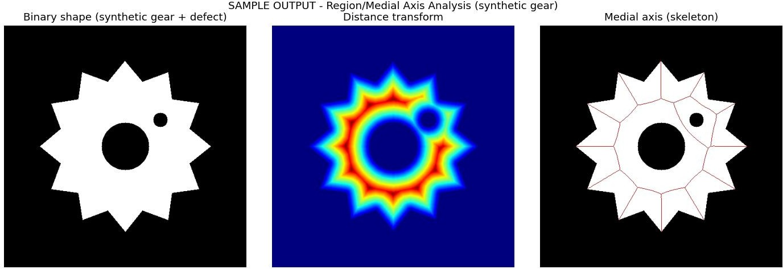
Fig. 2 — SAMPLE reference output: binary shape, distance transform, and medial axis, synthetic gear with defect.
Replace with your own result.

Documentation Checklist — fill this in with YOUR results
    - insert distance-transform heatmap and skeleton overlay for a normal part]
    - insert the same for a defective part with a hole/protrusion/missing region]
    - describe exactly how the skeleton's branch structure changed near the defect]
    - report the area/perimeter/Euler number difference between normal and defective parts]

Experiment 3: Deformable Curves and Snakes (Active Contours)
Scenario: Segment organs/objects with irregular boundaries. Input: 512x512 grayscale medical images (e.g., liver/heart slices) with mild Gaussian noise, DICOM or PNG.

Concept Summary
    - An Active Contour ('snake') is a deformable curve that evolves to minimize an energy functional E = E_internal + E_external.
    - E_internal (elasticity + curvature terms) keeps the curve smooth and continuous; E_external (image gradient / edge forces) pulls the curve toward object boundaries.
    - Unlike a fixed threshold, snakes can conform to irregular, non-convex organ boundaries and are robust to mild noise because the internal energy regularizes the curve.
    - Initialization matters: the snake needs to start reasonably close to the true boundary (e.g., a circle/ellipse around the organ) or it may converge to a local minimum / wrong edge.

Experimental Design (Pipeline)
    - Load grayscale image -> Gaussian blur to reduce noise while preserving the main edges the snake needs.
    - Manually or programmatically initialize a contour (e.g., a circle) around the region of interest.
    - Run active-contour segmentation (skimage.segmentation.active_contour) with tuned alpha (elasticity), beta (rigidity), and gamma (step size).
    - Overlay initial vs converged contour and compare against the visible organ boundary.

Template Code
  - Output (synthetic noisy blob — NOT your data)
Produced by running the code above on a computer-generated noisy blob standing in for an organ slice. Replace with output from your own medical image.
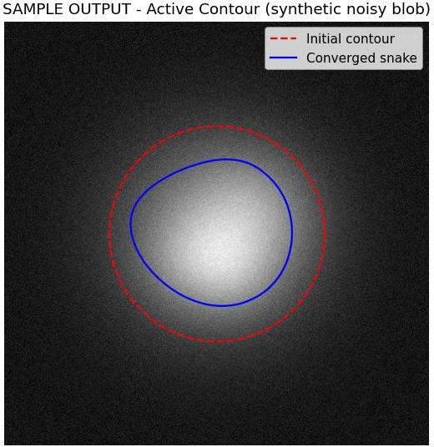
Fig. 3 — output: initial vs converged active contour, synthetic noisy blob. Replace with your own result.

Documentation Checklist — fill this in with YOUR results
    - insert the image with initial contour and final converged snake overlaid]
    - how closely does the converged snake follow the true organ boundary? Where did it fail (e.g., low-contrast edges)?]
    - show the effect of changing alpha/beta -- e.g., a higher beta producing a smoother but less detailed contour]

Experiment 4: Level Set Methods
Scenario: Track a moving object with evolving boundaries across a 30-frame video (e.g., a bouncing ball or moving hand), 640x480, MP4 or PNG sequence.

Concept Summary
    - A Level Set represents a contour implicitly as the zero-level curve of a higher-dimensional function phi(x, y, t), typically a signed distance function.
    - Instead of tracking boundary points directly (as snakes do), the level-set function evolves over time via a PDE, and the contour is recovered as {(x,y) : phi(x,y,t) = 0}.

    - This formulation naturally handles topological changes (splitting/merging of regions) that explicit parametric snakes struggle with.
    - For tracking, the level set can be re-initialized/evolved frame-to-frame using speed terms derived from image gradients or region statistics (e.g., Chan-Vese energy).

Experimental Design (Pipeline)
    - Extract frames from the video (or load the PNG sequence).
    - Initialize a level-set function phi (e.g., a signed-distance circle) around the object in frame 1.
    - Evolve phi for a fixed number of iterations per frame using a Chan-Vese-style region-based speed function.
    - Re-use the converged phi from frame t as the initialization for frame t+1 (this is what makes it 'tracking').
    - Extract and overlay the zero-level contour on each frame; assemble into an output video/GIF.

Template Code
import cv2
import numpy as np
from skimage.segmentation import morphological_chan_vese, checkerboard_level_set
cap = cv2.VideoCapture("moving_ball.mp4") frames = []
while True:
ret, frame = cap.read() if not ret:
break
frames.append(cv2.cvtColor(frame, cv2.COLOR_BGR2GRAY)) cap.release()

# Initialize level set on the first frame around the expected object location init_ls = checkerboard_level_set(frames[0].shape, 6)

results = [] ls = init_ls
for f in frames:
ls = morphological_chan_vese(f, num_iter=5, init_level_set=ls, smoothing=1)
results.append(ls.copy()) # ls==1 marks the tracked region for this frame
# Visualize contour on each frame
for i, (frame, mask) in enumerate(zip(frames, results)): overlay = cv2.cvtColor(frame, cv2.COLOR_GRAY2BGR)
contours, _ = cv2.findContours(mask.astype(np.uint8), cv2.RETR_EXTERNAL, cv2.CHAIN_APPROX_SIMPLE)
cv2.drawContours(overlay, contours, -1, (0, 0, 255), 2) cv2.imwrite(f"exp4_frame_{i:02d}.png", overlay)

Output (synthetic bouncing ball — NOT your data)
Produced by running the code above on 10 computer-generated frames of a ball moving across the frame. Replace with output from your own recorded video.
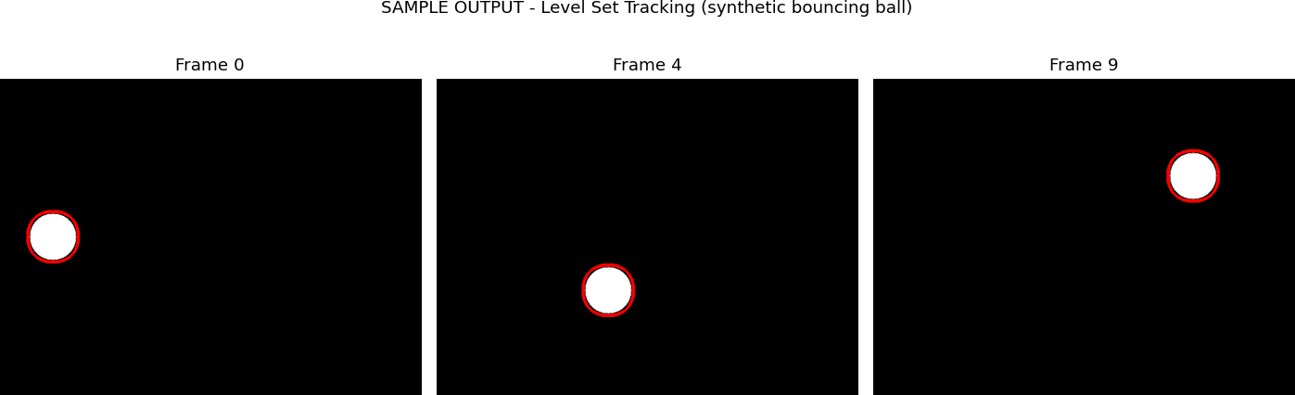

Fig. 4 — output: level-set contour tracking the object at frames 0, 4, 9, synthetic bouncing ball. Replace with your own result.

Documentation Checklist — fill this in with YOUR results
    - insert overlaid contour frames at t=0, mid, and final frame]
    - how well did the contour track the object as it moved/deformed? Did it lose the object at any frame?]
    - discuss how the level-set approach would handle the object splitting into two, versus what a snake would do]

Experiment 5: Multi-Resolution & Wavelet Descriptors
Scenario: Shape recognition at multiple scales (leaves, mechanical parts, coins). Input: grayscale images at 128x128, 256x256, 512x512, PNG.

Concept Summary
  - Experimental Design (Pipeline)
    - Load each object image at its native resolution and also resize copies to 128x128 / 256x256
/ 512x512 for direct scale comparison.
    - Build a Gaussian/Laplacian image pyramid (cv2.pyrDown / cv2.pyrUp) to visualize multi-resolution structure.
    - Apply a 2-level DWT (pywt.dwt2) to each resolution and extract LL/LH/HL/HH sub-bands.
    - Compute a feature vector (e.g., energy = mean of squared coefficients) per sub-band per scale.
    - Compare feature vectors across scales/objects to assess separability and scale robustness.

Template Code
import cv2
import numpy as np import pywt

import matplotlib.pyplot as plt

img = cv2.imread("leaf.png", cv2.IMREAD_GRAYSCALE)

# Gaussian pyramid (multi-resolution) pyramid = [img]
for _ in range(2): pyramid.append(cv2.pyrDown(pyramid[-1]))

# 2D DWT at each pyramid level def wavelet_energy(level_img):
LL, (LH, HL, HH) = pywt.dwt2(level_img, "haar") return {
"LL_energy": np.mean(LL ** 2), "LH_energy": np.mean(LH ** 2), "HL_energy": np.mean(HL ** 2), "HH_energy": np.mean(HH ** 2),
}

for i, level_img in enumerate(pyramid): feats = wavelet_energy(level_img)
print(f"Pyramid level {i} (size {level_img.shape}):", feats)

fig, ax = plt.subplots(1, len(pyramid), figsize=(10, 4)) for i, level_img in enumerate(pyramid):
ax[i].imshow(level_img, cmap="gray") ax[i].set_title(f"Level {i}: {level_img.shape}")
plt.savefig("exp5_pyramid.png")

Sample Reference Output (synthetic leaf shape — NOT your data)
Produced by running the code above on a computer-generated leaf-like shape at three pyramid resolutions. Replace with output from your own object images.
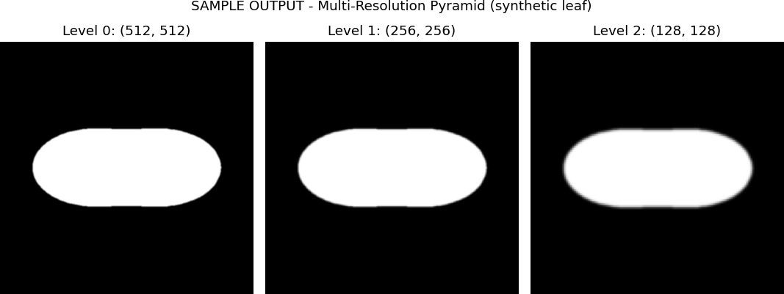

Fig. 5 — output: Gaussian pyramid at 512x512, 256x256, 128x128, synthetic leaf shape. Replace with your own result.
Wavelet sub-band energies measured for this sample (from the code's printed output):
    - Level 0 (512x512): LL=31154.2, LH=28.6, HL=8.8, HH=0.35
    - Level 1 (256x256): LL=30951.4, LH=81.7, HL=24.4, HH=1.76

    - Level 2 (128x128): LL=30510.7, LH=166.1, HL=52.6, HH=4.99

Documentation Checklist — fill this in with YOUR results
    - insert the pyramid image and a table of wavelet sub-band energies at each resolution]
    - how much does LL-band energy change as resolution changes, versus HH-band? What does this say about which sub-band is more scale-robust?]
    - compare wavelet descriptors between two different object classes -- e.g., leaf vs coin -- do they separate clearly?]

Final Notes
    - Run every code block on your own input images (matching the sizes/formats specified in the question) before writing your analysis.
    - Replace all placeholders with your actual screenshots, numbers, and interpretation -- this is what the rubric's 'Analysis of Results' and 'Documentation' criteria are graded on.
    - Sign the Code of Conduct declaration on the cover page only after the work is genuinely your own.

